# Assignment 5.1

Task Description #2 (Privacy & Security in File Handling)  
Task: Use an AI tool to generate a Python script that stores user data  
(name, email, password) in a file.  
Analyze: Check if the AI stores sensitive data in plain text or without  
encryption.  
Expected Output:  
• Identified privacy risks.  
• Revised version with encrypted password storage (e.g., hashing).

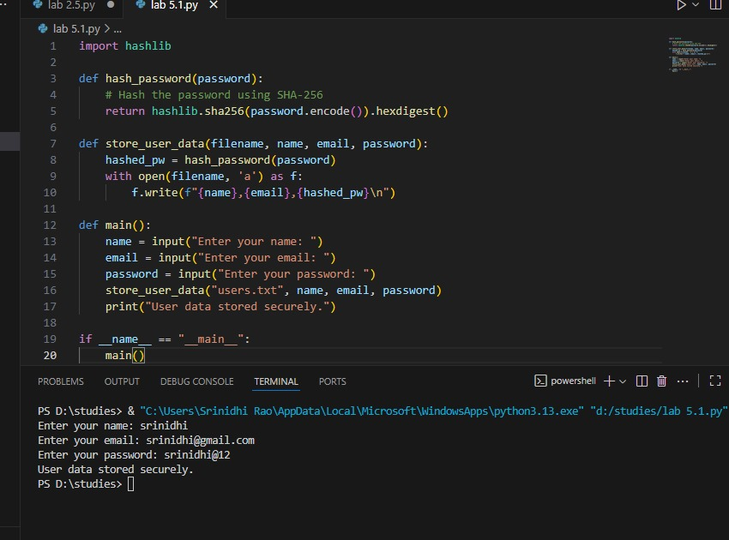

Task Description #3 (Transparency in Algorithm Design)  
Objective: Use AI to generate an Armstrong number checking function  
with comments and explanations.  
Instructions:  
1. Ask AI to explain the code line-by-line.  
2. Compare the explanation with code functionality.  
Expected Output:  
• Transparent, commented code.  
• Correct, easy-to-understand explanation

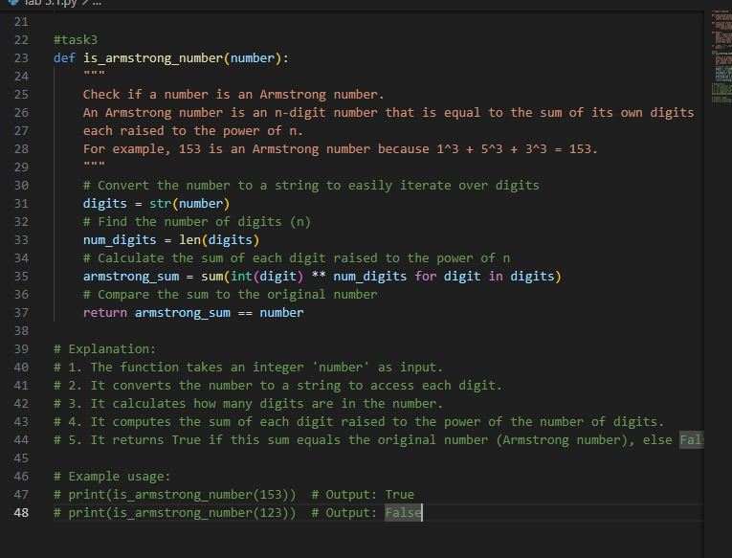

Task Description #4 (Transparency in Algorithm Comparison)  
Task: Use AI to implement two sorting algorithms (e.g., QuickSort and  
BubbleSort).  
Prompt:  
"Generate Python code for QuickSort and BubbleSort, and include  
comments explaining step-by-step how each works and where they  
differ."  
Expected Output:  
• Code for both algorithms.  
• Transparent, comparative explanation of their logic and  
efficiency

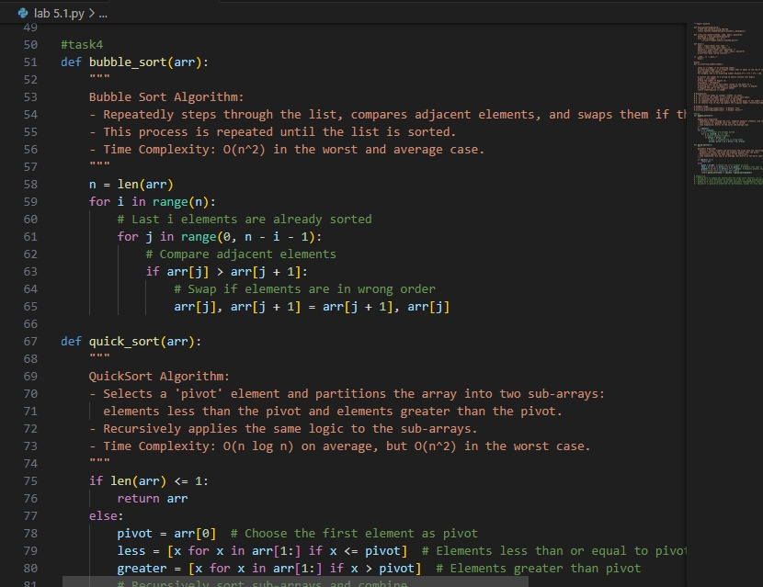

Task Description #5 (Transparency in AI Recommendations)  
Task: Use AI to create a product recommendation system.  
Prompt:  
"Generate a recommendation system that also provides reasons for  
each suggestion."  
Expected Output:  
• Code with explainable recommendations.  
• Evaluation of whether explanations are understandable

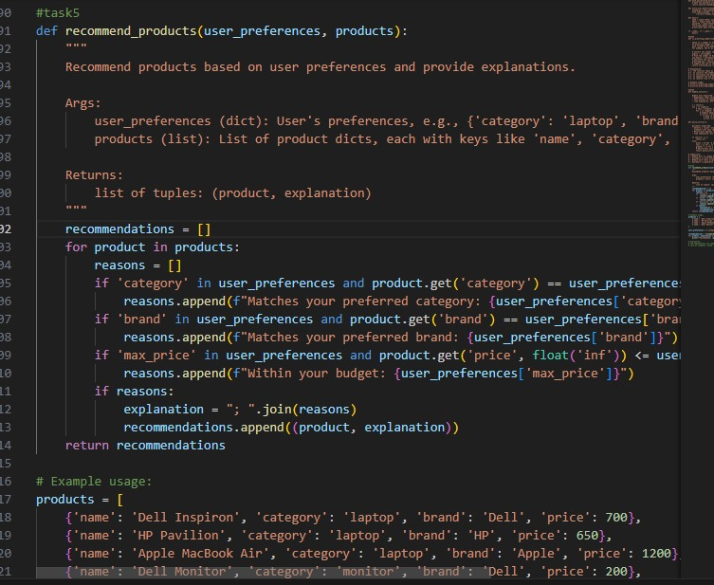

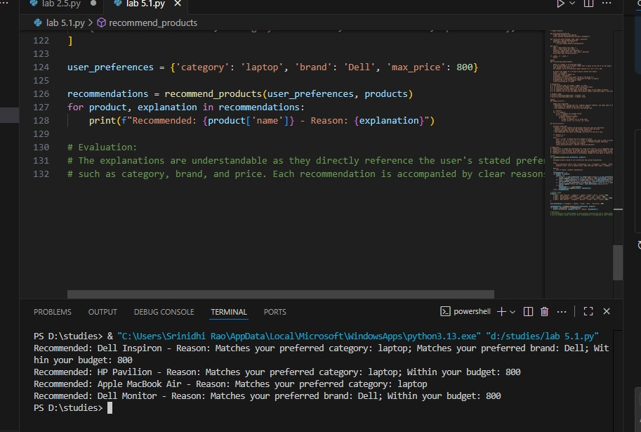

Task Description #6 (Transparent Code Generation)  
Task: Ask AI to generate a Python function for calculating factorial  
using recursion.  
Prompt:  
"Generate a recursive factorial function with comments that explain  
each line and a final summary of the algorithm’s flow."  
Expected Output:  
• Fully commented code.  
• Clear documentation of how recursion works.

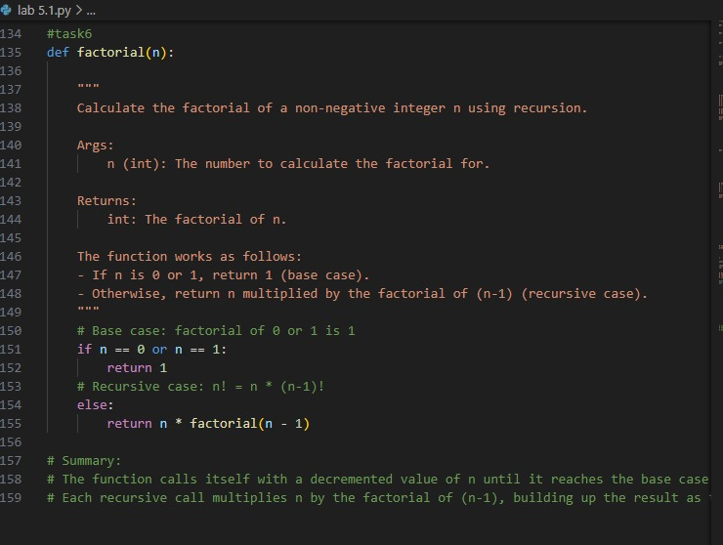

Explanation

The [factorial(n)](vscode-file://vscode-app/c:/Users/Srinidhi%20Rao/AppData/Local/Programs/Microsoft%20VS%20Code/resources/app/out/vs/code/electron-browser/workbench/workbench.html) function calculates the factorial of a non-negative integer [n](vscode-file://vscode-app/c:/Users/Srinidhi%20Rao/AppData/Local/Programs/Microsoft%20VS%20Code/resources/app/out/vs/code/electron-browser/workbench/workbench.html) using recursion.

* If [n](vscode-file://vscode-app/c:/Users/Srinidhi%20Rao/AppData/Local/Programs/Microsoft%20VS%20Code/resources/app/out/vs/code/electron-browser/workbench/workbench.html) is 0 or 1, it returns 1 (base case).
* Otherwise, it returns [n * factorial(n-1)](vscode-file://vscode-app/c:/Users/Srinidhi%20Rao/AppData/Local/Programs/Microsoft%20VS%20Code/resources/app/out/vs/code/electron-browser/workbench/workbench.html), repeatedly calling itself with smaller values until reaching the base case.
* This builds up the result as the recursive calls return, giving the product of all positive integers up to [n](vscode-file://vscode-app/c:/Users/Srinidhi%20Rao/AppData/Local/Programs/Microsoft%20VS%20Code/resources/app/out/vs/code/electron-browser/workbench/workbench.html).
* Task Description #7 (Inclusiveness in Customer Support)  
  Code Snippet:  
  Task:  
  Regenerate the code so that support messages use neutral language (e.g.,  
  “Dear {name}”) and optionally accept preferred titles.  
  Expected Output:  
  • Neutral, user-friendly support responses.
* 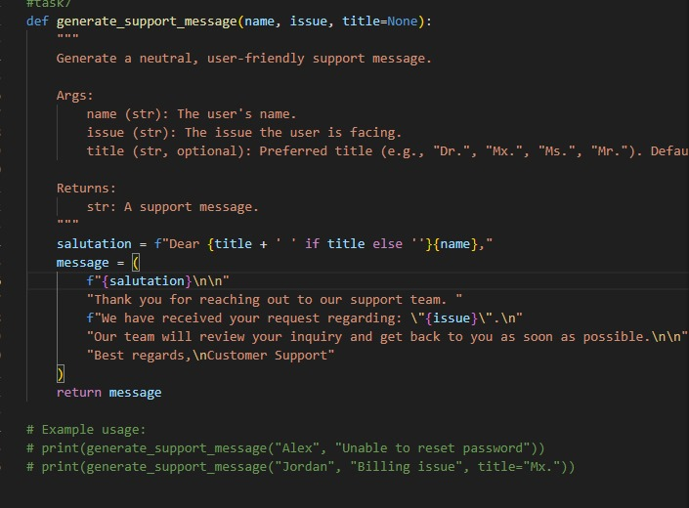
* Expalantion
* The [generate_support_message](vscode-file://vscode-app/c:/Users/Srinidhi%20Rao/AppData/Local/Programs/Microsoft%20VS%20Code/resources/app/out/vs/code/electron-browser/workbench/workbench.html" \o ") function creates a polite support reply for a user.  
  It takes the user's name, their issue, and an optional title, then formats a message acknowledging the issue and assuring a response from support.  
  This helps standardize and personalize customer communication.